FAAN TRAINING CENTRE

#### ARFFS Training Unit

**Aircraft Construction**

**INTRODUCTION**

The design and construction characteristics of aircraft have, over a 100 year period, made extraordinary advances. In the early 20th century aircraft were viewed as little more than the insane inventions of eccentric engineers. Now, in the 21st century it is clear to see that those early steps laid the foundations for what is an essential mode of transport.

Advances in technology have taken aircraft from their early fabric and balsa wood roots to the current specialist alloy and composite material construction.

It is important that Firefighters have a thorough knowledge of the design and construction characteristics of aircraft and recognise the hazards posed to them as they operate at aircraft incidents.

**AIM**

The aim of this note is to introduce students to the basic concepts of aircraft design and construction.

**OBJECTIVES**

After careful study of this training note and participation in theoretical and practical sessions of instruction, students will be able to:

* Define the basic terminology relating to aircraft design and construction
* Describe the general aircraft design characteristics
* State the main construction materials used
* Recognise the hazards posed to the Firefighter

**AIRCRAFT**

The term aircraft is used to describe all types of flying machines:

* Balloons
* Airships
* Rotary Wing (Helicopters, gyro planes etc.)
* Micro-lights
* Aeroplanes

For the purpose of this note we will concentrate on the **fixed wing aeroplane.**

**HOW DOES AN AEROPLANE FLY?**

In order to understand how an aeroplane flies it is first important to recognise the Bernoulli Principle or the Principle of Lift



In the above diagram we see the cross section of a typical aircraft wing. Due to the forward movement of the aircraft air flows above and below the wing. Because of the cross sectional shape of the wing, air must pass more quickly over the top of the wing than it does below. The pressure exerted by air on a surface over which it is passing, decreases as the speed of airflow increases, so, because air is travelling more quickly above the wing, a pressure difference is created. Higher pressure below the wing has the effect of pushing the wing up into the area of lower pressure above.

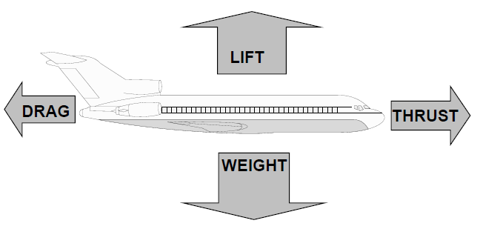

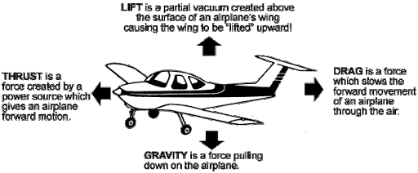

The Bernoulli Principle at work

An aeroplane, fully laden, can weigh up to 390 tonnes (390,000 kg). In order to make it fly it must be propelled forwards fast enough for the air moving over the wing surfaces to create sufficient pressure difference to overcome its overall weight. This is achieved using engines that provide sufficient thrust to overcome drag and provide the necessary speed.

**AEROPLANE LAYOUT**

To fully appreciate, and to effectively work with aircraft we not only need to have an understanding of the design and construction characteristics, we also need to learn the language. This section will define some of the terminologies that you will come across and use during your career.

**Note: Port = Pilot’s left**

**Starboard = Pilot’s right**



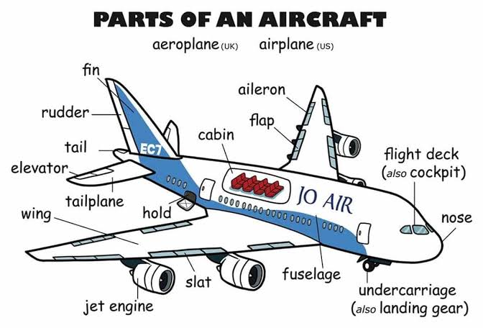

**BASIC FRAMEWORK**

The fuselage consists of vertical frames (sometimes called formers) which are placed transversely from nose to tail. Thinner sections of metal called stringers are then fitted horizontally onto the frames running the whole length of the fuselage.

Heavy gauge metal, longerons, run the whole length of the fuselage and the main task of these is to support the cabin floor.

The skin is stressed over the basic framework and contributes to the rigidity of the airframe. The thickness of the skin varies according to the stress which it must take. This system of construction is usually referred to as semi-monocoque.



**DIAGRAM SHOWING TYPICAL AIRCRAFT CONSTRUCTION**

**MAINPLANE (Wings)**

The mainplanes are supported by heavy sections of metal called spars which run from the centre of the fuselage to the wing tip or from wing tip to wing tip through the fuselage. The mainplanes are the main lifting surfaces of the aircraft and may contain fuel, engines, control systems and provide housing for the undercarriage units. The leading edge of the mainplane may be strengthened to take the pressure associated with high speed and the trailing edge houses the flaps and ailerons.

**TAIL UNIT (Empennage)**

The tail unit is constructed in much the same way as the mainplane. It consists of the tail plane which aids longitudinal stability and the tailfin which aids directional stability. Moveable control surfaces on the unit consist of elevators to control dive and climb and the rudder to control the direction of the aircraft.

**CONSTRUCTION MATERIALS**

The materials used in the construction of modern aircraft have changed as radically as the design. Timber frames and fabric skin have been replaced by a range of specialist metals and composite materials. It is important that Firefighters are aware of the main materials used, how they will behave if exposed to heat, what action will be needed in order to cut or spread the materials to gain access to trapped passengers and any hazards that the materials may present.

**The most commonly used materials are:**

* Aluminium alloy
* Magnesium alloy
* Titanium alloy
* Stainless steel
* Composite materials

The behaviour of these will vary considerably when involved in fire.

**ALUMINIUM ALLOY**

Aluminium alloy is used in vast quantities throughout the aircraft. Skin panels, aircraft frame sections, undercarriage and engine components, seat frames are all areas where aluminium alloys are used. The composition of the alloy will vary according to its task. The following is a guide to how it may react in a fire situation:

* The melting point of aluminium alloys is around 650oC
* At 200 oC, it will start to be affected by heat
* At 400 oC, due to rapid expansion it will buckle and distort
* At 600 oC, it will decompose (thicker sections will be weakened or will melt and drip)

Because temperatures in excess of 800 oC can be rapidly achieved by burning aviation fuel, and because of the high conductivity of Aluminium alloys they are very quickly affected in a fire situation. They will also cool rapidly when water or foam spray is applied.

Aluminium alloys can be readily cut with an axe, hacksaw, or power operated cutting tools. Care should be taken with sharp, jagged edges resulting from a crash situation and personnel should be aware of the danger from the needle sharp icicle-like formations resulting from the melting and cooling of the metal; these stalactites (i.e. icicles) are capable of penetrating even the best protective clothing.

**MAGNESIUM ALLOY**

Magnesium alloy is a light, strong metal which can be found in engine mounting brackets, crank cases in piston engines, compressor casings of turbine engines, and various strengthening brackets throughout the aircraft.

Magnesium alloy will start to melt at around 700 oC to 800 oC and burn at 900 oC to 1000 oC. When they are ignited they burn with a brilliant glare and are often difficult to extinguish as they will react with most fire fighting media.

‘D’ class chemical dry powders are designed to isolate and therefore contain the fire and can be used if available. However, normal fire fighting action with foam and/or water will create an increase in the already brilliant glare and there may be sporadic and spectacular flashes showering glowing particles around the area. If the fire fighting stream is maintained, it may cool the magnesium alloy until it solidifies and the fire is extinguished. If this fails it may be necessary to isolate the burning magnesium and allow it to burn itself out.

**TITANIUM ALLOY**

Titanium alloy is used where great strength or resistance to heat is required; its main use is in engine firewalls, tailpipe casings and turbine engine blades. It may also be used to make major components in high speed aircraft. Although not easily ignited it will begin to melt and burn between 1300 oC and 1450 oC.

Titanium alloy when involved in fire will react with most fire fighting media. However if ‘D’ class chemical dry powders are available it may be used but normal fire fighting streams will generally flood the area enough to bring the burning metal below its ignition temperature.

**With both magnesium and titanium alloy, cutting will generate showers of sparks. However, neither alloy is likely to be used to construct areas of an aircraft that may need to be cut.**

**STAINLESS STEEL**

Stainless steel is used where greater strength and rigidity is required such as frames which act as attachments for the mainplanes or beams to support engines, nut and bolts, parts of the undercarriage, and in some cases to reinforce skin surfaces and mainplanes on high speed aircraft.

Whilst stainless steel is not likely to be affected by the heat of a crash fire situation, it will conduct heat to other combustible materials and will retain its heat for some time.

After the bulk of the fire has been suppressed with normal fire fighting media, cooling with water spray will be needed to reduce the temperature of the steel.

**COMPOSITE MATERIALS**

The use of composite materials in the construction of modern aircraft is now extensive. Also components made from composites can be retrofitted to older aircraft.

Composite materials are also known collectively as Man Made Mineral Fibres (MMMF). The term MMMF describes a wide range of materials which utilise the inherent strength and durability of woven fibres bonded together with resins. Carbon Fibre Reinforced Plastic (CFRP), Aramid Reinforced Plastic (ARP), Glass Fibre Reinforced Plastic (GFRP) and Kevlar are all common names used to describe these materials.

They can be found virtually anywhere around an aircraft but they are particularly useful for the manufacture of control surfaces, cabin floor, engine cowlings and wheel bay doors.

The use of these materials combine the strength and durability of woven fibres bonded together with resins forming a composite having 5 times the strength of metal; kg for kg.

Although beneficial to the manufacturers and operators of aircraft, they pose some hazards to fire service personnel and others who would be in the vicinity of aircraft wreckage.

**TOXICITY**

The risk to personnel arises from the decomposition of the material both during and after the fire. The intense heat usually found at an accident site will decompose the resins bonding the fibres liberating toxic isocyanate fumes. The fibres within the composite will break into shorter and smaller lengths increasing their respirability and transportability. There is the possibility that the material may plume following a crash and be carried considerable distances downwind. In addition to the respiratory risk, fibres can easily cause needle stick injuries and traumatic dermatitis.

Carbon fibres are capable of absorbing all the products of the post-crash fire and if touched will act as an infection carrier enabling such products to enter the body.

**CONTAMINATION**

Three major areas of danger from composite materials found at crash sites have been identified. These include:

* Toxic vapours and dust released through the incineration of composite fibres
* Sharp filaments or splinters of material distributed or exposed by impact
* Gases released by burning resins

In each category there is a significant danger from the ingestion or inhalation of vapour, dust or splinters from any wreckage.

Firefighters must follow the safety measures which reduce the possibility of contamination not only to Firefighters but to other emergency service personnel who may be involved in rescue operations within the crash zone. This must include the wearing of full firefighting kit with breathing apparatus during any firefighting operations.

The periodic application of foam will reduce the risk of airborne pollution by MMMF and the general disturbance of the material within the aircraft wreckage.

Personnel engaged in rescue operations should be kept to a minimum commensurate with the scale of operations.

Special decontamination procedures may need to be implemented for personnel who have been involved in any incident involving MMMF.

**CONDUCTIVITY**

Airborne carbon fibre particles are conductive and if widely dispersed may damage electrical equipment and electrical installations.

**RESCUE**

Owing to its inherent strength, rescuers may find it particularly difficult to cut through composite materials and heat generating cutting equipment has little or no effect.

Fire damage will however significantly reduce the structural strengths of composite materials and whilst floor panels may appear intact, they are unlikely to support the weight of a Firefighter in such a condition.

**AIRCRAFT INTERIOR**

The size and layout of the interior of an aircraft fuselage can differ greatly depending on such aspects as aircraft type, size and also its intended use. In all cases, hidden away behind trim panels or under floors, may be components or aircraft service items that, in a fire situation, would become a significant hazard to aircraft occupants and Firefighters alike.

Examples of aircraft services that run the length and breadth of the fuselage are:

Electrical looms

* Air conditioning systems
* Hydraulic systems
* Anti-icing systems
* Heating services
* Fuel
* Water

Because of the pressure and temperature differences between outside the fuselage and inside during flight, there is a need for masses of insulating material to be used between the outer skin and interior trim. This insulation also cuts down the noise of engines to make a more pleasant environment for passengers.

The insulation is provided by various materials such as spun glass fibre, rock wool or polystyrene. In a fire situation they will melt and burn at relatively low temperatures giving off thick black toxic smoke. Because of the huge volumes of smoke that can be generated by these materials and the confined nature of an aircraft cabin, a potentially fatal atmosphere can develop very quickly. Also the source of the smoke can be difficult to locate.

Cabin furnishings and trim will also, if involved in a fire, contribute to making an internal fire probably the most difficult and hazardous a firefighter may have to deal with.

The following tables further explain the extent of the hazards:

CABIN FURNISHING MATERIALS, TOXIC GASES AND THEIR POTENTIAL EFFECT ON HUMANS

|  |  |  |
| --- | --- | --- |
| **Material** | **Typical Use** | **Toxic Gases** |
| Wool | Seats and Carpets | Cyanide  Ammonia  Nitrogen Dioxide |
| Nylon | Seats and carpeting | Cyanide  Ammonia |
| Acrylics | Glazing | Cyanide |
| Urethanes | Seating and Insulation | Cyanide  Ammonia  Nitrogen Dioxide |
| Poly Vinyl Chloride | Wiring Insulation Panelling and trim | Nitrogen Dioxide  Hydrogen Chloride  Halogen Acids  Carbon Dioxide  Carbon Monoxide |

The above are just a sample of the toxic materials which may be given off during a fire situation. Many others may be present. Some of the by-products given off during a fire can be lethal to humans in a very short time and for this reason rescue and fire fighting personnel should never enter an area where these may be present without breathing apparatus.

Examples of toxicity levels in “parts per million”

|  |  |  |
| --- | --- | --- |
| Carbon Monoxide | 400ppm | Distinct poisoning, frontal headache and nausea after 1 to 2 hours, death after 3 to 4 hours |
| 800ppm | Collapse after 1 hour, death after 2 hours |
| 1280ppm | Unconsciousness after 2 to 3 breaths, death in 1 to 3 minutes |
| Carbon Dioxide | 18000ppm | Breathing increased by 50% |
| 120000ppm | Immediate unconsciousness, death in minutes |
| Hydrogen Cyanide | 18 to 36ppm. | Headache after several hours |
| 100ppm | Fatal after 1 hour |
| 280ppm | Immediately Fatal |
| Nitrogen Dioxide | 10 to 20ppm | Mildly irritant to eyes, nose and upper respiratory tract |
| 80ppm | Tightness of chest after 3 to 5 minutes |
| 250ppm | Death after a few minutes |
| Ammonia | 200ppm | Irritation of the mucous membranes |
| 2000ppm | Fatal |
| Hydrogen Fluoride | 60ppm | Itching of skin. Irritation of respiratory tract after 1 minute |
| 50 - 100ppm | Dangerous to life after a few minutes |

OTHER INTERNAL HAZARDS

**Sealant**

A petroleum based sealant is sprayed on internal surfaces to prevent corrosion and dust. In a fire situation it will vaporise at 150 oC giving off flammable vapours.

**Pressurised Systems**

There are a number of pressurised systems that can be found inside an aircraft and will, in a fire situation, pose an explosion and projectile hazard. Some examples are:

* Oxygen cylinders
* Fire extinguishers
* Life jacket inflation cylinders
* Escape slide inflation cylinders
* Aerosols carried by passengers

In addition to the aircraft itself, items carried by passengers such as hand luggage and hold luggage will provide fuel for a fire. Galley utensils, food and alcoholic drinks should also be considered as a source of fuel.

**Fluorolastomers**

Fluorolastomers, of which Fluorolastomec and Viton are two examples, are simply flexible components that are capable of withstanding high pressures such as those found in hydraulic systems. They can often be found in modern aircraft.

The problem for the fire service comes when the material is exposed to heat above 315 oC when it is likely to decompose into a corrosive acid. This is Hydrofluoric acid. It is what is known as Calcium seeking and as such should be kept away from skin and bone as completely as possible. Provided personnel wear normal full protective equipment, there should be no problem. If contamination does occur, medical attention should be sought without delay.

**The major hazards associated with the design and construction of modern aircraft can be summed up by the following list:**

* **The rapid development and pluming of toxic vapours and dusts**
* **Sharp or jagged edges**
* **The possibility of structural collapse**
* **The involvement in fire of pressurised systems**
* **Hidden aircraft service lines**
* **Structural break up leading to trip hazards, trap hazards and the possibility of entanglement of rescue workers**
* **Numerous ignition sources**
* **Large volumes of flammable liquid**

**SUMMARY**

The construction of a modern aircraft is complex. In order to carry out their duties effectively and efficiently it is essential that all Firefighters have a sound basic understanding of how an aircraft is constructed, what materials are used in its construction; how those materials are likely to react during any fire or accident situation.

Because of the wide range of hazards associated with aircraft fires and accident situations where personnel are required to work in either smoke or dust of any description during an operational incident they should be required to wear full protective clothing and breathing apparatus.

**Firefighters must be made aware of the specific design and construction considerations of the aircraft that are frequently operating at their airport.**